To Study Exclusive-OR & Exclusive-NOR gate

OBJECTIVE:

- To investigate the behavior of the EX-OR
- To investigate the behavior of the EX-NOR

THEORY:
In Experiment 1&2, you learned the characteristics fundamental logic gate. You will now be introduced to two of the remaining logic gates, the EX-OR and EX-NOR. An exclusive OR (XOR) gate is gate with two or more three inputs and one output an output of two inputs XOR assumes a high state if one and only one input assume a high state. This is equivalent to saying that the output is a High if either input X or Y is high exclusively, and low when both are 1 and 0 simultaneously.
The Exclusive-NOR Gate function or Ex-NOR for short, is a digital logic gate that is the reverse or complementary form of the Exclusive-OR function. the output of an Exclusive-NOR gate ONLY goes “HIGH” when its two input terminals, A and B are at the “SAME” logic level which can be either at a logic level “1″ or at a logic level “0″.
EQUIPMENT / REQUIREMENT:

- 7486 IC XOR
- 74266 IC XNOR
- 2 LED or Logic probe
- 0-5 volt DC power supply

PROCEDURE:
Figure 2-1 shows logic symbols of XOR & XNOR Figure 2-2 shows the layouts of XOR gate IC (7486) & XNOR gate IC (74266).The pin configuration is also given in the layouts. Construct the circuit with the help of these layouts. Pin no. 7 and Pin no. 14 of each IC is Ground and VCC respectively, Apply different inputs on the given input pins and observe the out puts, and then complete the truth tables 3-1 and 3-2 of these gates.

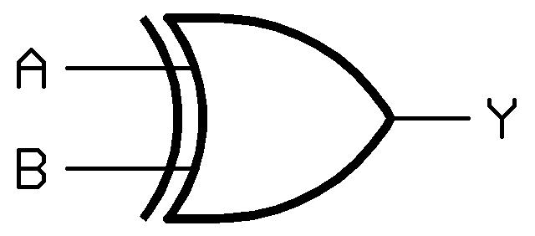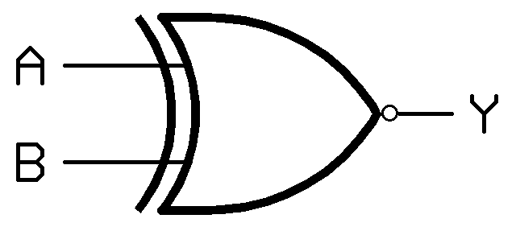

- XOR gate Symbol (b) XNOR gate Symbol

Fig3-1

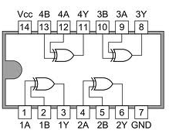
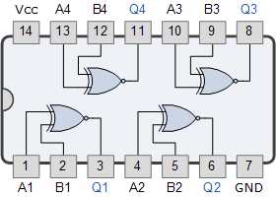

- IC configuration 7486 (b) IC Configuration 74266
Fig3-2

OBSERVATION TABLE:

A | B | 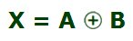
0 | 0
0 | 1
1 | 0
1 | 1
3-1 Truth Table for XOR gate

A | B | 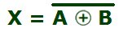
0 | 0
0 | 1
1 | 0
1 | 1
3-2 Truth Table for XNOR gate

QUESTIONS / RESULTS

- If the 0 and 1 were inputs for a XOR gate, what would be the output?
- If a signal passing through a gate is inhibited by sending a LOW into one of the inputs, and the output is LOW, the gate is an .
- XNOR provides the inverted output of an XOR. .

CONCLUSION:

